**UML Sequence Diagrams**

1. enterPayment

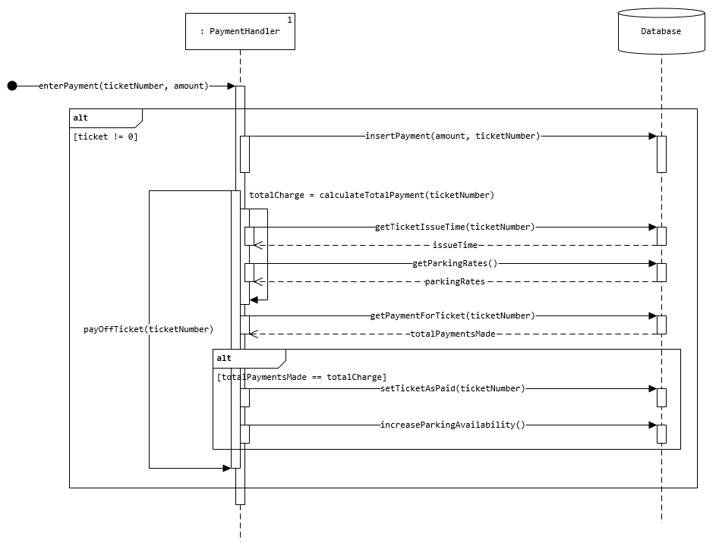

1. login

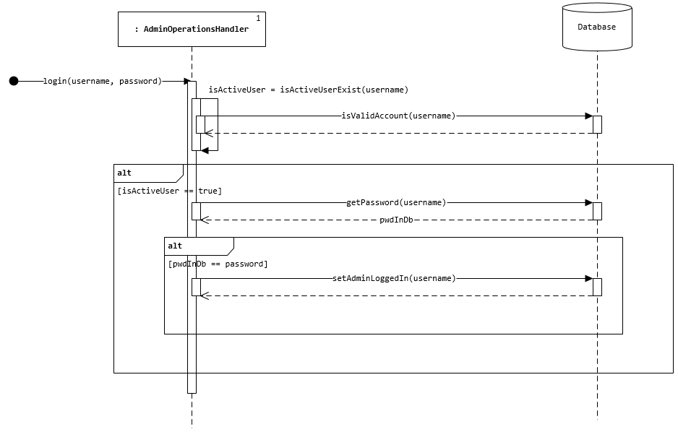

1. getMonthlyRevenueForYear

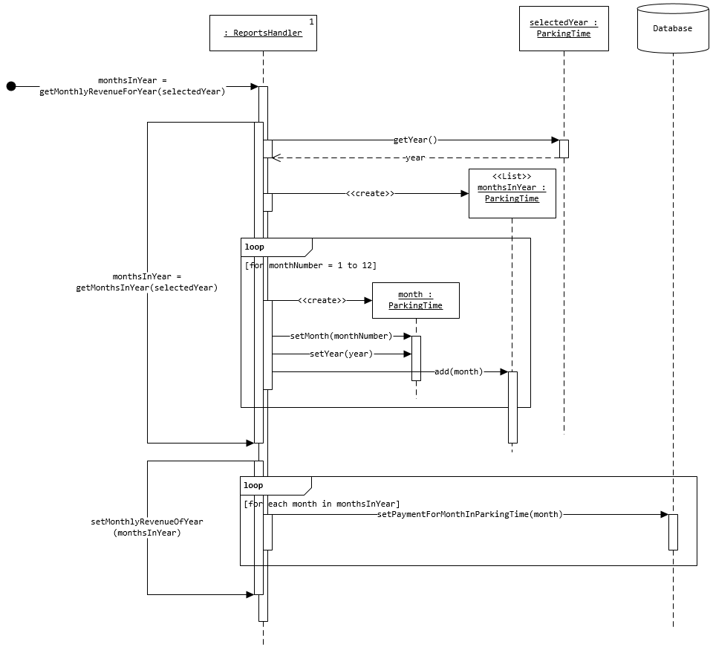

**Design Class Diagram**

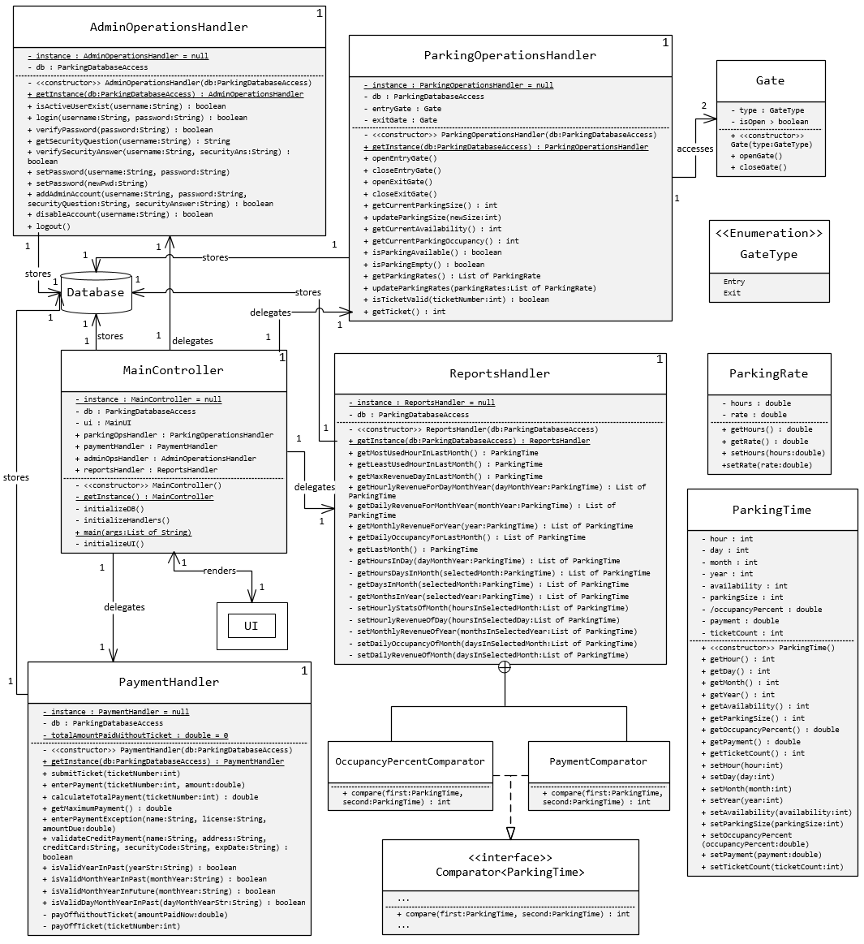

**Parking System Test Plan**

**Test Cases**

|  |  |
| --- | --- |
| Test Case No. | 1 |
| Test Description |  |
| Module being Tested |  |
| Importance |  |
| Test Steps |  |
| Expected Results |  |
| Actual Results |  |
| Cleanup |  |